Remarks：
- This Report Card aims to help students establish their training objectives, understand their skill levels and challenge themselves.

- Please fill in your best training results in the page。

- Certificate of Attendance
Students with an attendance rate of 80% or above (i.e. attending at least 8 lessons in the same term) will receive a Certificate of Attendance.

- Athletics Badges Award Scheme
Students with an attendance rate of 60% or above and results that meet the required standard of their age group will receive a Certificate of Diamond, Gold, Silver or Bronze Badge issued by the LCSD as encouragement.

- Please keep this Report Card until the course is completed.

- Persistence is a requisite for good results in athletic training. Teachers should therefore remind students to be punctual for lessons.
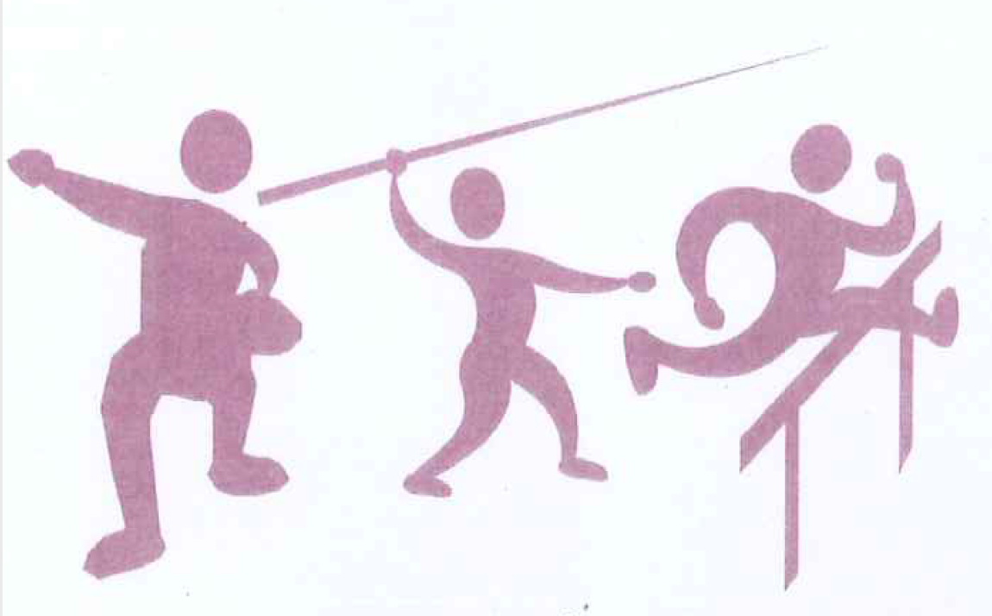

Organised by the Hong Kong, China Association of Athletics Affiliates
Subvented by the Leisure and Cultural Services Department
Co-organised by the Education Bureau

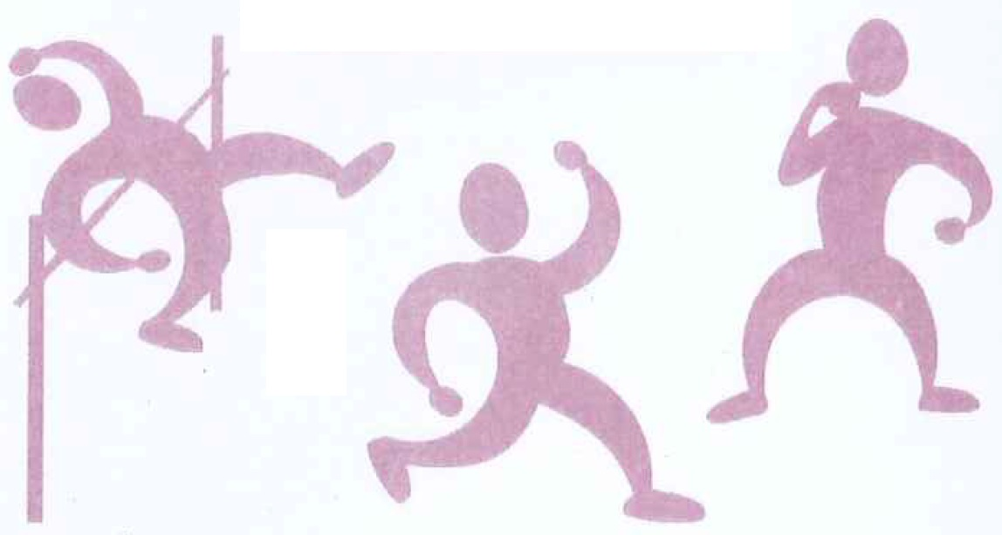

Joint Schools Athletics Training Programme

Report Card

School Name：
Student Name：
Course Code：
Course Date：

School Sports Programme – Joint Schools Athletics Training Programme
Standards and Assessment of the Athletics Badges

Men | Badges | 60m  (s’) | 100m  (s’) | 200m  (s’) | 800m  (m:s’) | 1500m  (m:s’) | 100/110m  Hurdles (s’) | High jump (m) | Long jump (m) | Triple jump (m) | Short put (m) | Discus (m) | Javelin (m) | Softball (m)
Group A  Aged 17 or above |  |  |  |  |  |  | 110m/0.914m |  |  |  | 5.0kg | 1.5kg | 700g
Group A  Aged 17 or above | Diamond  Gold  Silver  Bronze |  | 11.90  12.20  12.60  12.80 | 24.60  25.50  26.10  26.50 | 2:15.00  2:20.00  2:30.00  2:34.00 | 4:58.00  5:00.00  5:12.00  5:30.00 | 17.70  18.50  20.00  20.30 | 1.65  1.60  1.55  1.50 | 5.80  5.45  5.10  4.90 | 12.10  11.20  10.50  10.30 | 10.60  10.05  9.10  8.90 | 31.00  26.00  21.00  20.00 | 34.00  30.00  26.00  23.00
Group B  Aged 15-16 | Diamond  Gold  Silver  Bronze |  |  |  |  |  | 100m/0.914m |  |  |  | 4.0kg | 1.0kg | 600g
Group B  Aged 15-16 | Diamond  Gold  Silver  Bronze |  | 12.10  12.50  13.00  13.30 | 25.40  26.40  26.80  27.30 | 2:21.00  2:23.00  2:30.00  2:40.00 | 5:00.00  5:04.00  5:20.00  5:40.00 | 16.20  17.00  19.80  20.00 | 1.59  1.52  1.47  1.45 | 5.30  5.05  4.70  4.60 | 11.20  10.50  9.50  9.40 | 10.90  10.10  9.30  9.10 | 32.00  27.00  23.00  22.00 | 33.00  25.50  20.00  18.00
Group C  Aged 13-14 | Diamond  Gold  Silver  Bronze |  |  |  |  |  | 100m/0.838m |  |  |  | 4.0kg | 1.0kg
Group C  Aged 13-14 | Diamond  Gold  Silver  Bronze |  | 12.80  13.30  13.70  14.10 | 26.40  27.50  29.00  29.60 | 2:25.00  2:32.00  2:43.00  2:53.00 | 5:20.00  5:25.00  5:45.00  5:58.00 | 18.60  19.70  21.00  21.80 | 1.46  1.38  1.30  1.25 | 5.00  4.55  4.10  3.80 |  | 9.10  8.30  7.30  7.25 | 25.00  20.00  17.00  15.00
Group D  Aged 11-12 | Diamond  Gold  Silver  Bronze |  |  |  |  |  |  |  |  |  | 3.0kg
Group D  Aged 11-12 | Diamond  Gold  Silver  Bronze | 8.60  9.00  9.50  9.90 | 13.40  13.90  14.30  15.20 | 27.60  28.70  30.20  32.00 |  |  |  | 1.35  1.27  1.15  1.10 | 4.20  3.70  3.30  3.00 |  | 8.50  7.80  6.80  6.00 |  |  | 45.00  38.00  32.00  25.00
Group E  Aged 9-10 | Diamond  Gold  Silver  Bronze | 8.80  9.20  9.70  10.00 | 14.00  14.50  15.20  16.10 |  |  |  |  |  | 3.90  3.50  3.10  2.80

Women | Badges | 60m  (s’) | 100m  (s’) | 200m  (s’) | 800m  (m:s’) | 1500m  (m:s’) | 100m  Hurdles (s’) | High jump (m) | Long jump (m) | Triple jump (m) | Short put (m) | Discus (m) | Javelin (m) | Softball (m)
Group A  Aged 17 or above |  |  |  |  |  |  | 0.762m |  |  |  | 4.0kg | 1.0kg | 600g
Group A  Aged 17 or above | Diamond  Gold  Silver  Bronze |  | 13.80  14.50  15.30  15.70 | 28.90  30.50  32.00  33.50 | 2:45.00  2:55.00  3:09.00  3:18.00 | 5:55.00  6:15.00  6:50.00  7:00.00 | 18.00  19.50  21.00  22.50 | 1.45  1.30  1.26  1.23 | 4.50  4.10  3.70  3.60 |  | 7.40  6.90  6.40  6.15 | 21.50  18.80  16.50  15.00 | 24.00  19.00  15.00  14.00
Group B  Aged 15-16 | Diamond  Gold  Silver  Bronze |  |  |  |  |  | 0.762m |  |  |  | 3.0kg | 1.0kg | 500g
Group B  Aged 15-16 | Diamond  Gold  Silver  Bronze |  | 13.90  14.60  15.50  15.90 | 29.50  30.80  32.20  33.50 | 2:48.00  2:55.00  3:10.00  3:19.00 | 6:05.00  6:25.00  6:50.00  7:00.00 | 19.00  20.20  21.20  23.00 | 1.40  1.30  1.23  1.20 | 4.40  4.00  3.60  3.40 |  | 8.00  7.25  7.10  6.60 | 20.00  18.00  15.20  14.00 | 21.00  17.80  13.50  12.00
Group C  Aged 13-14 | Diamond  Gold  Silver  Bronze |  |  |  |  |  | 0.762m |  |  |  | 3.0kg | 1.0kg
Group C  Aged 13-14 | Diamond  Gold  Silver  Bronze |  | 14.50  15.20  15.60  16.00 | 30.00  31.50  33.00  34.00 | 2:51.00  2:57.00  3:12.00  3:25.00 | 6.20.00  6:30.00  6:50.00  7:00.00 | 20.00  21.00  22.20  24.00 | 1.35  1.25  1.20  1.15 | 4.20  3.80  3.40  3.10 |  | 7.60  7.00  6.30  6.00 | 18.50  16.00  12.50  11.00
Group D  Aged 11-12 | Diamond  Gold  Silver  Bronze |  |  |  |  |  |  |  |  |  | 3.0kg
Group D  Aged 11-12 | Diamond  Gold  Silver  Bronze | 9.00  9.30  9.70  10.10 | 14.70  15.40  15.80  16.10 | 30.90  31.70  33.50  34.80 |  |  |  | 1.30  1.20  1.15  1.08 | 4.00  3.60  3.20  2.90 |  | 7.00  6.40  5.90  5.30 |  |  | 33.00  29.00  24.00  20,00
Group E  Aged 9-10 | Diamond  Gold  Silver  Bronze | 9.20  9.60  10.00  10.40 | 15.20  15.90  16.40  17.10 |  |  |  |  |  | 3.30  2.90  2.50  2.30

Result Record
Date
Result
Items
 | 1st term |  |  | 2st term |  |  | Badges Award Assessment Day
Running events：
100m / 110m Hurdles (s’)
60 / 100 m (s’)
200 m (m:s’)
400 m (m:s’)
800 m (m:s’)
1500 m/ 5000 m/10000 m (m:s’)
Jumping events：
Long jump (m)
Triple jump (m)
High jump (m)
Throwing events：
Discus (m)
Javelin (m)
Short put / Softball (m)

