
Please
Affix
Stamp Here

Booking Form and Booking Guide for Holiday Camps
(Applicable for Schools and Other Groups / Organisations with Priority Booking Status or
Non-SmartPLAY Patrons)
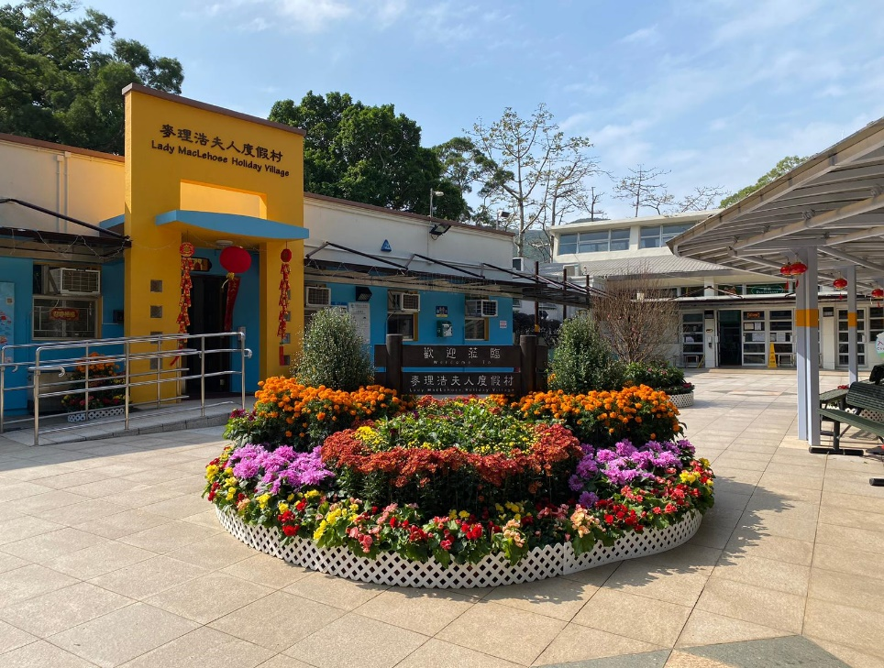 | 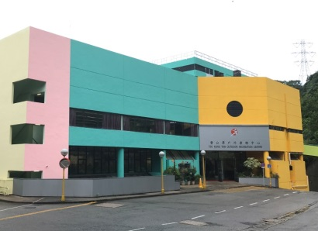 | 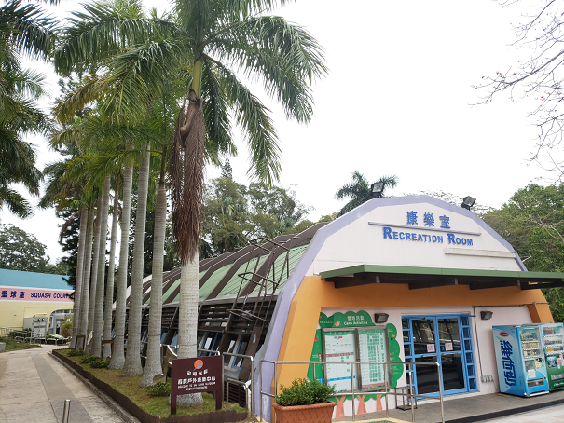 | 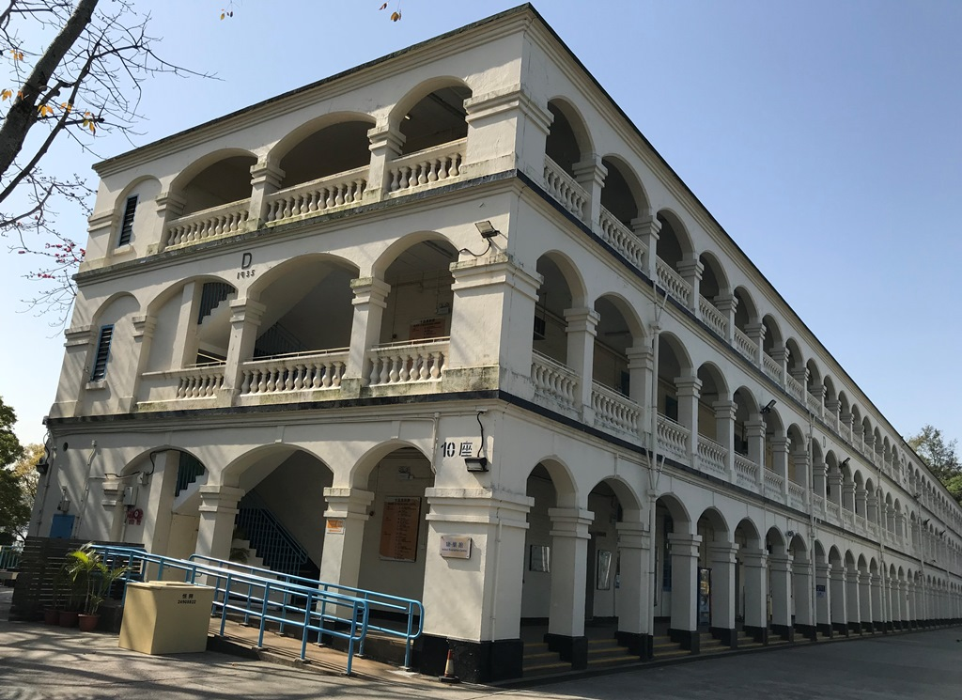
Lady MacLehose Holiday Village | Tso Kung Tam Outdoor  Recreation Centre | Sai Kung Outdoor  Recreation Centre | Lei Yue Mun Park

TO： | ◻ | Lady MacLehose Holiday Village  Pak Tam, Sai Kung, New Territories (Fax: 2792 0254 / email: lmhv@lcsd.gov.hk)
 | ◻ | Tso Kung Tam Outdoor Recreation Centre  105 Route Twisk, Tsuen Wan, New Territories (Fax: 2492 4436 / email: tktorc@lcsd.gov.hk)
 | ◻ | Sai Kung Outdoor Recreation Centre  21 Hong Kin Road, Tui Min Hoi Area, Sai Kung, New Territories (Fax: 2792 0203 / email: skorc@lcsd.gov.hk)
 | ◻ | Lei Yue Mun Park  75 Chai Wan Road, Hong Kong (Fax: 2568 8304 / email: lymp@lcsd.gov.hk)
(Please put a “✓” in the appropriate box ◻ )

--------------------------------------------(Please fold and seal with adhesive tape)----------------------------------------------
- To make booking up to 6 months in advance (Schools and Other Groups / Organisations with Priority Booking Status)
Submit the completed booking form to the holiday camp concerned by post, email or fax.
- To book camp places within 10 days (Non-SmartPLAY patrons)
Check the availability of camp places with the holiday camp concerned by telephone. If there are places available, email or fax the completed booking form to the camp concerned and arrange for payment of camp fee.
Contact information of holiday camps
Lady MacLehose Holiday Village  Address: Pak Tam, Sai Kung, N.T.  Telephone: 2792 6430 / 2792 6417  Fax: 2792 0254  Email: lmhv@lcsd.gov.hk | Tso Kung Tam Outdoor Recreation Centre  Address: 105 Route Twisk, Tsuen Wan, N.T.  Telephone: 2417 1107 / 2415 6812  Fax: 2492 4436  Email: tktorc@lcsd.gov.hk |  | Sai Kung Outdoor Recreation Centre  Address: 21 Hong Kin Road, Tui Min Hoi Area, Sai Kung, N.T.  Telephone: 2792 3828 / 2792 0046  Fax: 2792 0203  Email: skorc@lcsd.gov.hk | Lei Yue Mun Park  Address: 75 Chai Wan Road, Hong Kong  Telephone: 2568 7455 / 2568 7858  Fax: 2568 8304  Email: lymp@lcsd.gov.hk
Office hours of LCSD District Leisure Services Offices and recreation and sports venues with SmartPLAY services for booking and payment
Lady MacLehose Holiday Village, Tso Kung Tam Outdoor Recreation Centre, Sai Kung Outdoor Recreation Centre and Lei Yue Mun Park:
Monday to Friday : 8:30 am - 4:00 pm / Saturday: 8:30 am - 11:00 am (Closed on Sunday and public holidays)
LCSD District Leisure Services Offices:
Monday to Friday: 8:30 am - 4:30 pm (Closed on Saturday, Sunday and public holidays)
Offices of LCSD recreation and sports venues with SmartPLAY services:
Monday to Sunday : 8:30 am - 10:00 pm (Open on public holidays)
For official use only
Form No.:
Camp Fee:HK$
Receipt No.:

Holiday Camp Booking Form

(Applicable for Schools and Other Groups / Organisations with Priority Booking Status or Non-SmartPLAY patrons)

Points to Note | - Please read the Holiday Camp Booking Guide carefully before completing this form.  - Please put a “✓” in the appropriate boxes.  - Applicants must provide the required personal data clearly on this form. Failure to do so may result in the LCSD being unable to process their applications.  - The information provided will only be used for services arrangement (including meals, compilation of statistics, future correspondence, promotion of activities and verification of identity when arranging refund for cancelled camp bookings). Only those who are authorised by this Department will be given access to the personal data provided by applicants.  - For correction of or access to the submitted data, please contact the respective camp manager.
Holiday Camp to be Booked
◻ Lady MacLehose Holiday Village (LMHV) ◻ Tso Kung Tam Outdoor Recreation Centre ◻ Sai Kung Outdoor Recreation Centre ◻ Lei Yue Mun Park
Particulars of Applicant
(Applicants must be 18 years of age and holders of recognised identity documents. They are required to produce the original or a copy of their identity documents when making payment.)
Name of Organisation (for bookings made in the name of an organisation only):
Name (English): Name (Chinese): Sex: ◻ Male ◻ Female Age ^{Note 1}:
(should be identical to the one shown on the identity document) (should be identical to the one shown on the identity document)
Identity Document No.: |  |  |  |  |  |  |  |  | ◻ Hong Kong Resident ^{Note 2}
 |  |  |  |  |  |  |  |  | ◻ Non-Hong Kong Resident ^{Note 3}
Contact No.: (Day) (Night) Mobile: Fax No.:
Email Address: Correspondence Address:
Booking Purpose(s): ◻ Leisure ◻ Cultural ◻ Education ◻ Training ◻ Others (Please specify)
Intended Camping Date(s)
For ◻ Day Camp / ◻ Evening Camp |  |  |  |  |  |  | For Residential Camp
Order of Preference |  | Check-in Date |  |  |  |  | Order of Preference |  |  | Check-in Date |  |  |  | to | Check-out Date |  |  | Total No. of Night(s)
1st choice |  | Day | Month |  | Year |  | 1st choice |  |  | Day |  | Month | Year | to | Day | Month | Year
2nd choice |  | Day | Month |  | Year |  | 2nd choice |  |  | Day |  | Month | Year | to | Day | Month | Year
3rd choice |  | Day | Month |  | Year |  | 3rd choice |  |  | Day |  | Month | Year | to | Day | Month | Year
- Each booking form can only be used for booking camping periods in the same month. (For residential camp bookings, the above table can still be used if the camping period straddles 2 months. Please refer to “Booking Procedures” on the last page for details.)
- Please use separate forms for booking residential camp, day camp and evening camp in the same month.
Number and Status of Campers (including the applicant) (This part must be completed)
 |  |  |  |  |  |  |  |  |  | Notes:  - Applicants must have reached 18 years of age on or before the check-in date.  - A “Hong Kong resident” refers to a holder of recognised Hong Kong identity documents including the Hong Kong Identity Card (HKIC). Children aged under 11 may produce their HKIC, Birth Certificate, Document of Identity for Visa Purposes, HKSAR Re-entry Permit or One-way Permit.  - A “Non-Hong Kong resident” refers to a holder of valid travel documents issued by a place other than the Hong Kong Special Administrative Region.  - Campers who apply for the concessionary rate or waiver of the camp fee are required to produce the original or a copy of their valid identity documents for verification when checking in. If campers are found to have failed to meet the eligibility criteria or the actual number of campers exceeds the number of campers stated on the booking form, they will be required to make up the difference in the camp fees immediately.  - Rehabilitation service agencies recognised by the Social Welfare Department (SWD) are eligible for the concessionary rate. Nevertheless, the ratio of persons with disabilities to their accompanying carers should not exceed 1:1.  - Holders of the Registration Card for People with Disabilities issued by the Central Registry for Rehabilitation or other valid identity documents and one of their accompanying carers are eligible for the concessionary rate.  - The concessionary rate is available to full-time students (i.e. students studying full-time in local or overseas primary or secondary schools, universities or vocational training schools (including full-time student nurses)), local schools (kindergartens and primary and secondary schools) and subvented organisations registered with the SWD on weekdays only. Local schools and subvented organisations registered with the SWD should apply in the name of organization and submit in written application.
  Types of Camp Fee |  | Eligible Group(s) |  | No. of Camper(s)
  Full rate |  | Persons aged 14 to 59
  Concessionary rate ^{Note 4}  (Leave blank  if not applying for concession) |  | Persons aged 3 to 13
   |  | Persons aged 60 or above
  Groups of persons with disabilities
  (PWDs) ^{Note 5} / PWDs ^{Note 6}
   |  | Accompanying carers of PWDs ^{Note 5/6}
   |  | Local schools / Full-time students ^{Note 7}
   |  | Subvented organisations registered with the Social Welfare Department ^{Note 7}
  Fee waived ^{Note 4} |  | Persons aged under 3
  Total
  Status of Campers | No. of Hong Kong Residents ^{Note 2} |  | No. of Non-Hong Kong Residents  (Country / Territory of Domicile) ^{Note 3}
  Applicant |  |  | ( )
  Other campers |  |  | ( )
Other information:
- A participant’s age is calculated as at the check-in date.
- If Tropical Cyclone Signal No. 3 or above or the Black Rainstorm Warning Signal is in force at 7:00 am on the check-in day, all day camp bookings will be cancelled. If Tropical Cyclone Signal No. 3 or above or the Black Rainstorm Warning Signal is still in force at 12:00 noon, all residential camp and evening camp bookings will also be cancelled. Campers may apply for refund of the camp fee. Please retain the receipt issued by the LCSD for refund applications.
- Please contact the camp staff to enquire about the camping arrangements before setting off for the camp if the Red Rainstorm Warning Signal is in force on the check-in day.
- The camp fee paid will not be refunded except in the event of the closure of the holiday camp due to inclement weather or other circumstances.

Bookings for the LMHV only (This part must be completed)
- I / We □ shall / □ shall not take the shuttle bus(es) arranged by the LCSD for transport between Sai Kung Town Centre and the LMHV.
- I / We □ shall / □ shall not arrange for our own coach(es) (with 16 seats or more) to the LMHV.
Declaration
- I have reached the age of 18 and hold valid identity documents. I hereby apply for holiday camp places on behalf of the aforementioned campers.
- I declare that all campers aged under 18 have obtained their parent’s / guardian’s consent to their participation in camp activities. All campers and I are healthy, physically fit and suitable to participate in the above activities.
- I have thoroughly read the booking guide and declare that all the information given above is true and correct. I will inform the camp staff as soon as possible of any subsequent change in the information or cancellation of the booking.
- I declare that I book the session and facility as a user. I undertake to cancel the booked session and facility according to the means specified in the Conditions of Use of Recreation and Sports Facilities in the event that I fail to check-in for the booked session and be present during the use of the facility for any reason, and will not engage in any form of transfer of user permit.
- I, on behalf of (name of organisation/group) (hereinafter referred to as “the organisation/group”), declare that the session and facility hired by the organisation/group is only used for event organised by the organisation/group and undertake to notify the venue office of the cancellation of the booking at least 20 days before the date of use in the event that the booked session and facility are not used for any reason, and will not engage in any form of transfer of user permit.

Applicant’s Signature: Date: Chop of Organisation:
Please put down either your fax number/email or address for future correspondence. |  |  |  | Name: Fax/Email:  Address:

Holiday Camp Booking Guide
- The primary objective of our holiday camps is to provide leisure services for Hong Kong residents.
- Applicants must be at least 18 years of age and the holder of valid identity documents.
- All campers must leave the holiday camps when their booked camping periods are over.
- The Department does not accept any travel agents’ application for hiring the holiday camps for commercial guesthouses.
- Applicants who are non-Hong Kong residents /non-SmartPLAY patrons can only book camp places available from the current date to the next 10 days, inclusive of the day of booking.
- In the event of booking cancellations by applicants or absence of participants, the payment is non-refundable.
- The application will be rendered null and void if the type(s) of camp places and camping period applied for are found to have overlapped.
- If there is any adjustment to the camp fees or meal charges, applicants will be notified at the time of payment. Receipts will also be issued to them upon payment.
- Payment by post should be in the form of a crossed cheque made payable to “The Government of the Hong Kong Special Administrative Region” or “The Government of the HKSAR”. Post-dated cheques will not be accepted.
- The camp staff will verify the applicants’ identity documents on check-in.
- Applicants and all of their accompanying campers must observe both the “General Conditions of Use of LCSD Holiday Camps” and “Conditions of Use of LCSD Recreation and Sports Facilities”.
- The Department reserves the right to reject any unqualified applications.
- Applicants shall ensure that no act or activity which is likely to constitute or is likely to cause the occurrence of an offence endangering national security under the National Security Law or other laws of Hong Kong or which would otherwise be contrary to the interests of national security. Please refer to the “General Conditions of Use of LCSD Holiday Camps” in the Booking Form and Booking Guide for Holiday Camps on LCSD Holiday Camps website.

Number of Camp Places and Check-in/Check-out Time
Number of Camp Places
Holiday Camp | Residential Camp  | Day Camp | Evening Camp
Lady MacLehose  Holiday Village | - Bungalows each with 3-15 beds  - Minimum: 3 persons  - Maximum: 268 persons | Maximum  200 persons | Maximum  100 persons
Tso Kung Tam  Outdoor Recreation Centre | - Dormitories each with 10 beds  - Minimum: 10 persons or multiples of 10  - Maximum: 240 persons | Maximum  200 persons | Maximum  100 persons
Sai Kung Outdoor Recreation Centre | - Dormitories each with 8 beds  - Minimum: 8 persons or multiples of 8  - Maximum: 248 persons | Maximum  310 persons | Maximum  100 persons
Lei Yue Mun Park | - Dormitories each with 3-5 beds  - Capacity of group hostels: 50  - Capacity of family hostels: 232  - Minimum: 3 persons  - Maximum: 282 persons | Maximum  300 persons | Maximum  100 persons
★ Applicants should book by the dormitory/bungalow

Check-in/Check-out Time
Residential Camp | Day Camp | Evening Camp
Check-in  2:30 pm on arrival day  Check-out  1:00 pm on departure day  (Each stay is limited to a maximum of four consecutive nights only) | Check-in  9:30 am  Check-out  4:30 pm | Check-in  4:30 pm  Check-out  10:30 pm

Camp Fees
Type of Camp | Camping Date | Full Rate |  | Concessionary Rate
Type of Camp | Camping Date | 14 to 59 years of age |  | Campers aged 3 to 13 / 60 or above, groups of persons with disabilities (PWDs), PWDs each with an accompanying carer |  | Full-time students, local schools and subvented organisations registered with the Social Welfare Department  (Weekdays only)
Day Camp  and  Evening Camp | Weekdays  (Monday to Friday except public holidays) | $17 |  | $8.5 |  | $8.5
Day Camp  and  Evening Camp | Saturday, Sunday and public holidays | $26 |  | $13 |  | Not applicable
Residential  Camp   (May to October) | Weekdays  (Sunday to Friday except the night preceding a public holiday) | $57 | $66  (Family hostel) | $28.5 | $33  (Family hostel) | $28.5 | $33  (Family hostel)
Residential  Camp   (May to October) | Saturday nights and the night preceding a public holiday | $81 | $90  (Family hostel) | $40.5 | $45  (Family hostel) | Not applicable
Residential  Camp  (November to April) | Weekdays  (Sunday to Friday except the night preceding a public holiday) | $41 | $50  (Family hostel) | $20 | $25  (Family hostel) | $20 | $25  (Family hostel)
Residential  Camp  (November to April) | Saturday nights and the night preceding a public holiday | $59 | $73  (Family hostel) | $30 | $36.5  (Family hostel) | Not applicable
⧫ Air conditioning is provided in rooms from 4:00 pm to 8:00 am the following day between May and October
■ Family hostels are only available at Lei Yue Mun Park

Meal Charges (to be collected by camp restaurants)
- The camp fee does not include meal charges. Campers who need catering service from the camp are required to place their order with the restaurant by phone, email or fax at least 1 week before the check-in date, and confirm with the restaurant themselves.
- Meal charges are subject to adjustment in line with movement in the Consumer Price Index (A). Campers may approach the relevant camp office or restaurant for latest information.
Holiday Camp | Residential camp | Day camp | Evening camp | Barbecue pack (utensils included)
Holiday Camp | Breakfast, lunch and dinner | Lunch | Dinner | Barbecue pack (utensils included)
Lady MacLehose Holiday Village | $80.8 per head | $31.8 per head | $31.8 per head | $44.9 per pack
Tso Kung Tam Outdoor Recreation Centre | $80 per head | $31.5 per head | $31.5 per head | $45 per pack
Sai Kung Outdoor Recreation Centre | $80.6 per head | $31.6 per head | $31.6 per head | $44.3 per pack
Lei Yue Mun Park | $83.2 per head | $32.6 per head | $32.6 per head | $45.6 per pack

Booking Procedures
Booking camp places available within 10 days for non-SmartPLAY patrons
Non-SmartPLAY patrons could only book camp places available within 10 days (including the booking day) from the current date. They should call the office of the holiday camp concerned direct. The deadline for booking of evening and residential camps is one day before the check-in date. The LCSD may, however, consider on-the-spot bookings depending on the actual circumstances.
Booking arrangement for Schools and Other Groups/Organisations with Priority Booking Status
- Local schools (including kindergartens, primary schools, secondary schools and special schools) and groups/organisations with priority booking status (including higher education institutions recognised by government departments and the Education Bureau, subvented non-governmental organisations registered with the Social Welfare Department, charitable organisations registered with the Inland Revenue Department and National Sports Associations recognised by the Sports Federation & Olympic committee of Hong Kong, China) can reserve day/evening/residential camp places 6 months in advance. This arrangement is applicable to camp places on regular school days only (i.e. from Monday to Friday). It does not apply to day/ evening/ residential camp places on public holidays, and residential camp places on the day preceding a public holiday.
- Groups/organisations should submit the completed booking form, together with documentary proof that they have registered with relevant departments/organisations, to the holiday camp concerned by post, email or fax by the submission deadlines.
- Submission deadlines are listed as follows:
Month of intended use | Submission deadline |  | Month of intended use | Submission deadline |  | Month of intended use | Submission deadline
January | 30/6 of the preceding year |  | May | 31/10 of the preceding year |  | September | 28/2 or 29/2 of the same year
February | 31/7 of the preceding year |  | June | 30/11 of the preceding year |  | October | 31/3 of the same year
March | 31/8 of the preceding year |  | July* | 31/12 of the preceding year |  | November | 30/4 of the same year
April | 30/9 of the preceding year |  | August** | Not applicable |  | December | 31/5 of the same year
* For July, local schools and groups/organisations with priority booking status can only make this arrangement for camp places on school days as specified by the Education Bureau.
** Since there are no school days in August, this arrangement is not available for local schools and groups/organisations with priority booking status.
- Camp places will be allocated by ballot, which is held at 3:00 pm on the fifth working day of the sixth month prior to the camping date (e.g. the ballot for places in May will be held on the fifth working day of November of the preceding year) at the office of the holiday camp concerned.
- Local schools will be given priority in the ballot.
- Successful applicant schools and groups/organisations will be notified in writing of the payment method.
- Schools interested in booking camp places left unfilled after the ballot may contact the office of the holiday camp concerned direct.
- For successful applications, if all campers of a group/organisation fail to check in without a valid reason, a default notice will be served on the group/organisation concerned. Within 12 months after the serving of the first default notice, if the group/organisation concerned is served with a second default notice across LCSD holiday camps in any type of camp place, its eligibility for 6-month advance priority booking will be suspended for 12 months. LCSD will reserve the right to reject its future applications for camp places.
- If a group/organisation with priority booking status fails to provide documentary proof that it has registered with relevant departments/organisations, its application will not be processed.
- For details, please visit the following website:
https://www.lcsd.gov.hk/en/camp/booking_guide/booking_procedures.htmI
Online enquiry
- Information on LCSD Holiday Camps: https://www.lcsd.gov.hk/tc/camp/index.html
- Camp places available within 30 days: Please click the relevant option on the left of the webpage in (1) above to check the number of camp places available at each holiday camp
- Holiday Camp Booking Form: https://www.lcsd.gov.hk/tc/aboutlcsd/forms/lcs45.html

LCS45a (Revised in 5/2024)

